

Super Easy Homemade Wormery

Step 1
Drill about twenty evenly spaced holes in the bottom of each bin. These holes will provide drainage and allow the worms to crawl into the second bin when you are ready to harvest the castings.
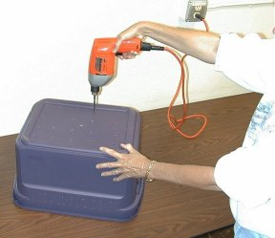
Step 2
Drill ventilation holes about 1 – 1 ½ inches apart on each side of the bin near the top edge. Also drill about 30 small holes in the top of one of the lids.

Step 3
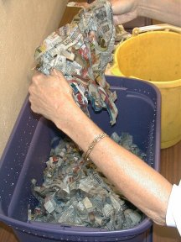
Prepare bedding for the worms by shredding. Newspaper into 1 inch strips. Worms need bedding that is moist but not soggy. Moisten the newspaper with water. Cover the bottom of the bin with 3-4 inches of moist newspaper, fluffed up. If you have any old leaves or leaf litter, that can be added also. Throw in a handful of dirt for "grit" to help the worms digest their food.
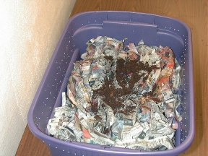

Step 4
Add your worms to the bedding. One way to gather redworms, is to put out a large piece of wet cardboard on your lawn or garden at night. The redworms live in the top 3 inches of organic material, and like to come up and feast on the wet cardboard! Lift up cardboard to gather the redworms. Or, if you wish you can purchase worms. An earthworm can consume about 1/2 of its weight each day. For example, if your food waste averages 1/2 lb. per day, you will need 1 lb. of worms or a 2:1 ratio.
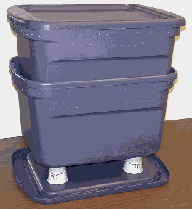

Step 5
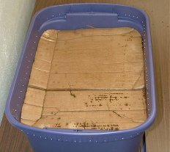
Cut a piece of cardboard to fit over the bedding, and get it wet. Then cover the bedding with the cardboard. (Worms love cardboard, and it breaks down within months.)

Step 6
Place your bin in a well-ventilated area such as a laundry room, garage, balcony, under the kitchen sink, or outside in the shade. Place the bin on top of blocks or bricks or upside down plastic containers to allow for drainage. You can use the lid of the second bin as a tray to catch any moisture that may drain from the bin. This "worm tea" is a great liquid fertilizer.

Step 7
Feed your worms slowly at first. As the worms multiply, you can begin to add more food. Gently bury the food in a different section of the bin each week, under the cardboard. The worms will follow the food scraps around the bin. Burying the food scraps will help to keep fruit flys away.
What do worms like to eat? Feed your worms a vegetarian diet.(see the list below). You will notice that some foods will be eaten faster than others. Worms have their preferences just like us.

Feeding your worms:

Worms LOVE | Worms HATE
Breads & Grains  Cereal  Coffee grounds & filter  Fruits  Tea bags  Vegetables | Dairy Products  Fats  Meat  Feces  Oils
When the first bin is full and there are no recognizable food scraps, place new bedding material in the second bin and place the bin directly on the compost surface of the first bin. Bury your food scraps to the bedding of the second bin. In one to two months, most of the worms will have moved to the second bin in search of food. Now the first bin will contain (almost) worm free vermicompost. (You can gently lift out any worms that might remain, and place them in the new bin, or put them into your garden!)

Troubleshooting
Problem | Probable Cause | Solution
Worms are dying or trying to escape | Too wet  Too dry  Bedding is used up | Add more bedding  Moisten bedding  Harvest your bin
Bin stinks! | Not enough air  Too much food  Too wet | Drill more ventilation holes  Do not feed for 1-2 weeks  Add more bedding
Fruit Flys | Exposed food | Bury food in bedding

Curriculum Strands Addressed:
Natural environments
Environmental awareness and care.
Living things
Construction

