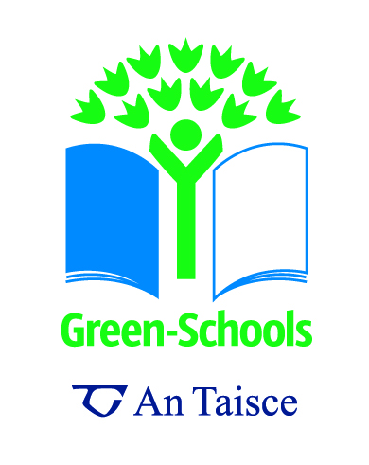
Sample Awareness Questionnaire for Junior Classes

- Do you know what 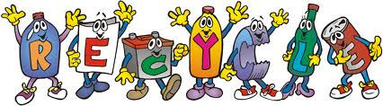 means?
No = 
Yes = 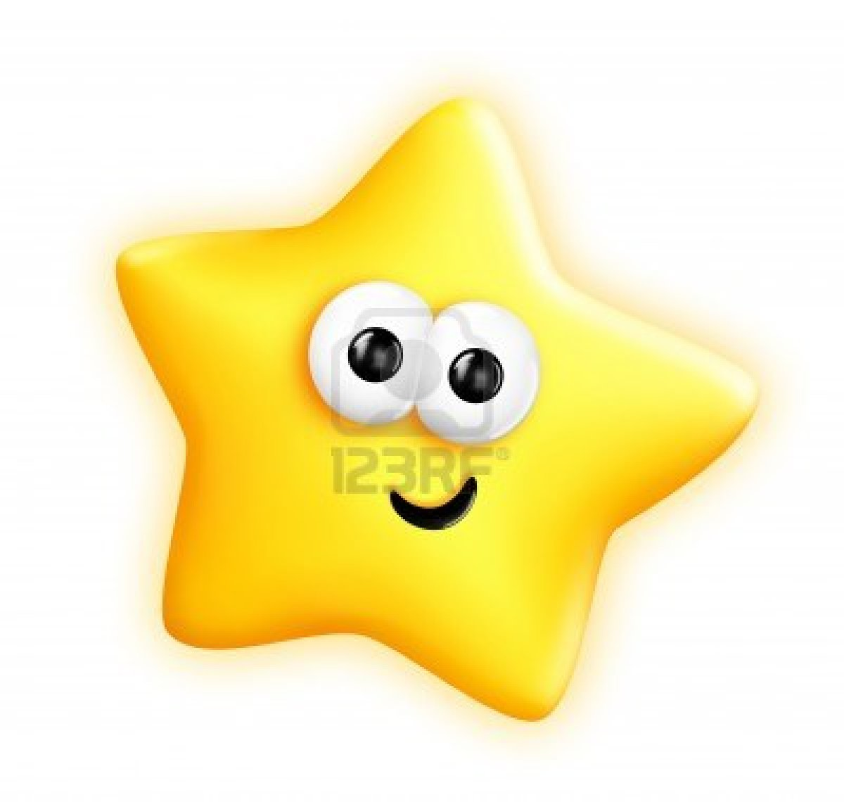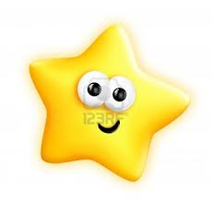
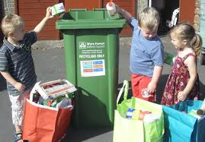

No =
Yes =
- Do you know what this symbol means?
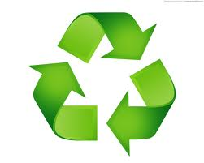

No =
Yes =
- Do you know why we recycle?

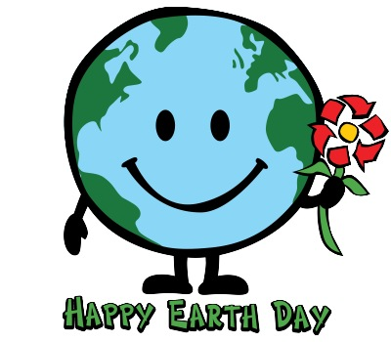

No =
Yes =
- Do you know what these bottles are made from?

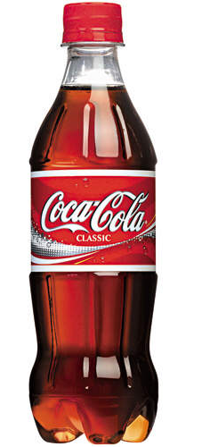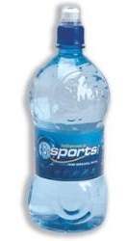

- Do you know what the little boy is doing?
No =
Yes =
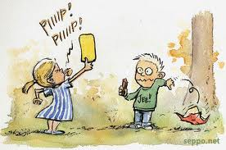

© Seppo Leinonen
No =
Yes =
- Is this litter?

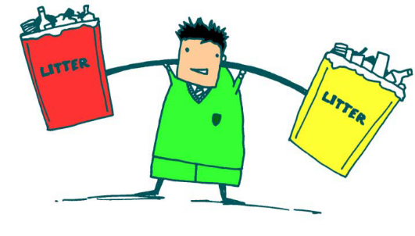

- Is littering bad? And why?
No =
Yes =
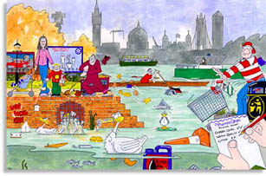

- Can we do anything to stop littering?
No =
Yes =
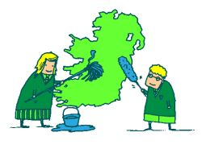

Images:
Image 1 – The recycle word available from http://alcoa.typepad.com/recycling/2010/06/recycle-guys-reach-out-to-nc-school-children.html
Image 2 – The children recycling from http://www.thekiddiesdaynursery.co.uk/2010/07/09/eco-friendly-collection-day-today/
Image 3 – The Mobius recycling symbol from http://dddigitalcolour.com/recyclig/green-recycling-symbol/
Image 4 – The Earth Day image from http://www.twincitieslist.com/events/celebrate-earth-day-at-totally-kids/
Image 5 – Coke and Water Bottle from http://www.ballygowan.ie/additional-services.html and http://www.coca-cola.ie/
Image 6 – A child littering from http://www.seppo.net/cartoons/displayimage.php?pid=1037 (permission given to use in a non commercial manner)
Image 7 – Cartoon image of person with 2 bins from http://www.greenschoolsireland.org/case-studies/litter-and-waste.220.html
Image 8 – Drawing of impacts of littering from http://marine-litter.gpa.unep.org/kids/kids.htm
Image 9 – Cartoon image of people cleaning Ireland from http://www.greenschoolsireland.org/resources/litter-and-waste.429.html

